TC-DVA-002
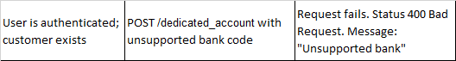
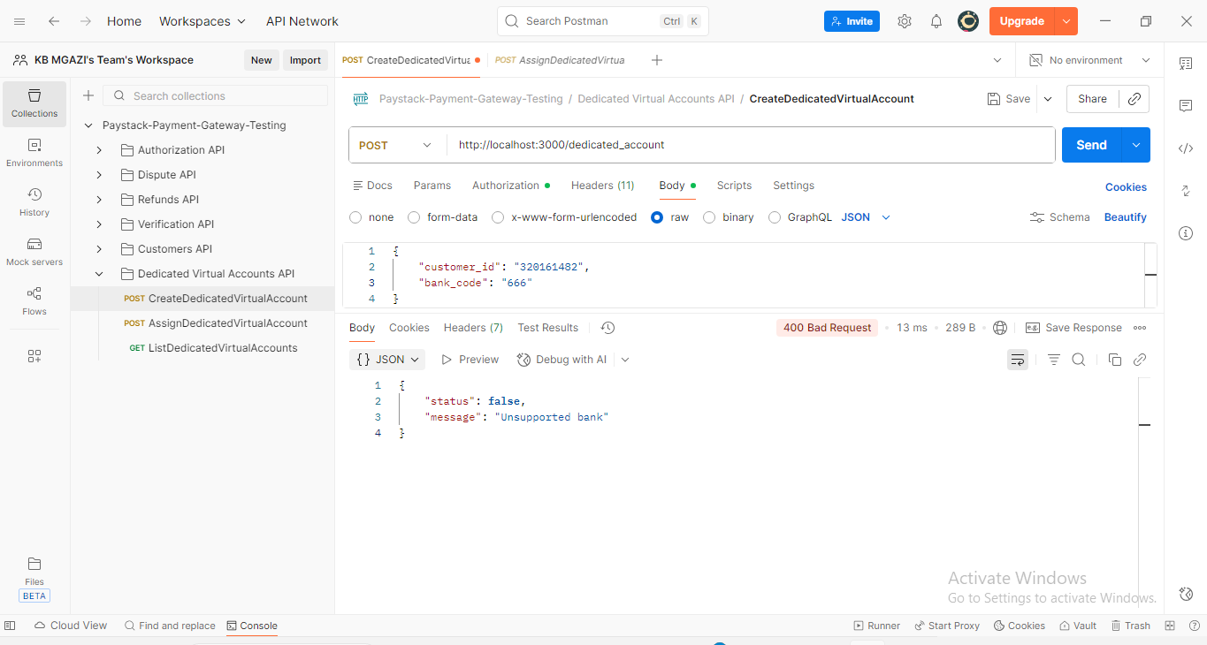
Request:
{
"customer_id": "320161482",
"bank_code": "666"
}

Response:
{
"status": false,
"message": "Unsupported bank"
}

